Task 2: Core Cybersecurity Concepts Explainer
Cybersecurity is about safeguarding computers, accounts, networks and information so that they are not used in ways or harmed. I have seen incidents where this is overlooked.
Cybersecurity has ideas but some basic ideas are important to learn first. In this document I have described five ideas with everyday examples. I hope you find them useful.
The five concepts are:
1. Confidentiality
2. Integrity
3. Availability
4. Authentication vs Authorization
5. Threat vs Vulnerability vs Risk

1. Confidentiality
### What does it mean?
Confidentiality means ensuring that information is seen by people who are permitted to see it. I think confidentiality is essential for protecting data.
For example your personal messages, passwords and bank details should not be visible to people.
### Real-World Scenario
Imagine a student who has a college account that holds personal information, marks and phone number. I have seen students forget to log out. The student uses a password to protect the account. One day the student uses a computer in a place and accidentally leaves the account logged in. Another person uses that computer. Opens the student’s account. That person can now see the student’s information. In this situation confidentiality has been broken because a person who was not supposed to see the information was able to access it. I feel uneasy when my own data is exposed.
A simple way to remember confidentiality is:
"Who is allowed to see this information?"
2. Integrity
### What does it mean?
Integrity means making sure that information stays correct and is not changed without permission. I think integrity is as important as confidentiality. It is not enough for information to be private. It also needs to remain accurate.
### Real-World Scenario
Imagine a student’s online college marks are stored in a database. The student originally received 85 marks for an examination. However someone gains access to the system and changes the mark from 85 to 55. The information is still available. Can still be viewed, but it is no longer correct. This means integrity has been violated because the original information was changed without permission. I am concerned when data is altered without my knowledge.
A simple way to remember integrity is:
"Has the information been changed or damaged?"
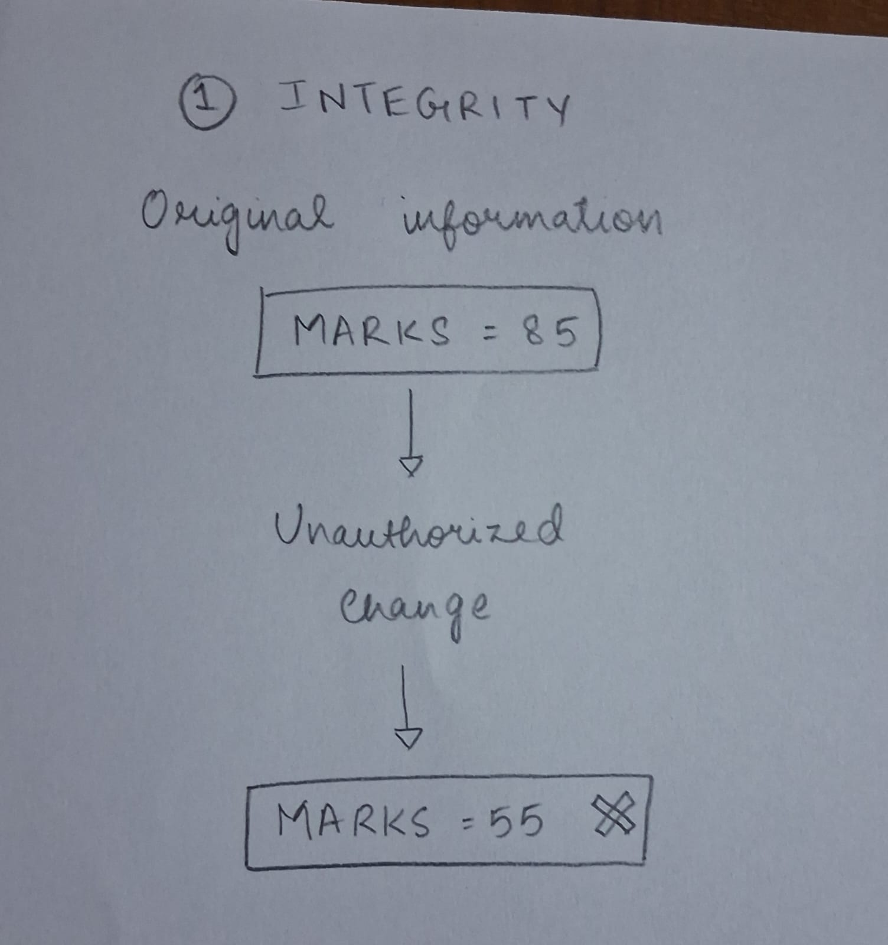

3. Availability
### What does it mean?
Availability means making sure that a system or information is accessible when authorized users need it. I have experienced frustration when a system is down at a moment. Even if information is private and accurate it is not useful if nobody can access it when needed. I remind myself that availability is essential.
### Real-World Scenario
Imagine a college that uses a portal for students to register for examinations. Registration opens at 10 AM. Thousands of students try to access the website at the time. However the website becomes overloaded and stops responding; it looks like the website is a bit of a failure. Students cannot log in. Register. The information may still be secure and correct. Students cannot access the service when they need it. This is an availability problem. I would not want to miss a deadline if the system fails.
A simple way to remember availability is:
"Can I access it when I need it?"
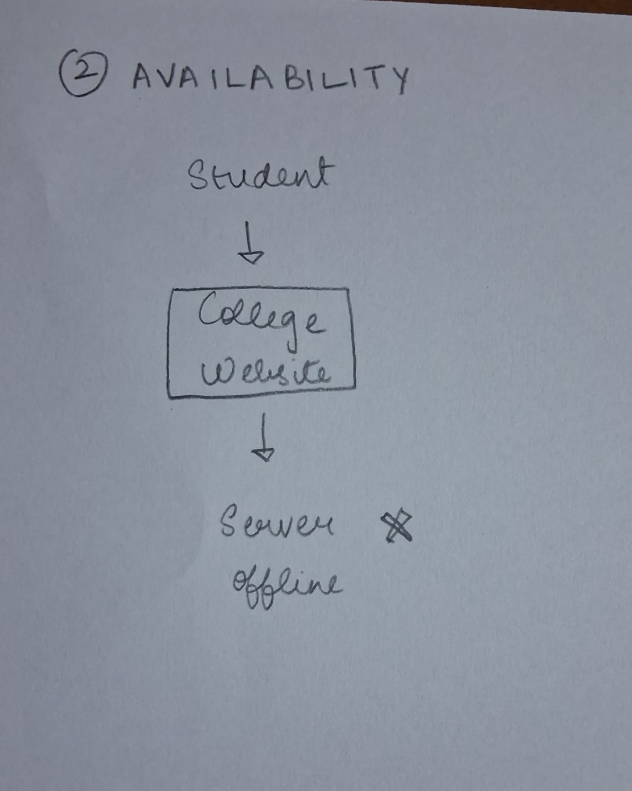

# 4. Authentication, vs Authorization
These two terms sound similar. They mean different things. I will explain how they differ.
### Authentication
**Authentication means proving who you are.**
For example when you enter your username and password to log into your college account the system verifies that you are really the account owner.
### Authorization
**Authorization means deciding what you are allowed to do after your identity has been verified.**
For example a student and a college administrator can both log in. They will not have the same permissions.
The student might be allowed to view their marks while the administrator might be allowed to enter or change marks.
### Real-World Scenario
Consider a college computer system.
First I enter my username and password.
The system checks my details. Confirms:
**"Yes this is the correct user."**
That is authentication.
After logging in I try to open the administrator section. The system checks my permissions. Says I am not allowed to access it.
That is authorization.
So:
**Authentication = Who are you?**
**Authorization = What are you allowed to do?**
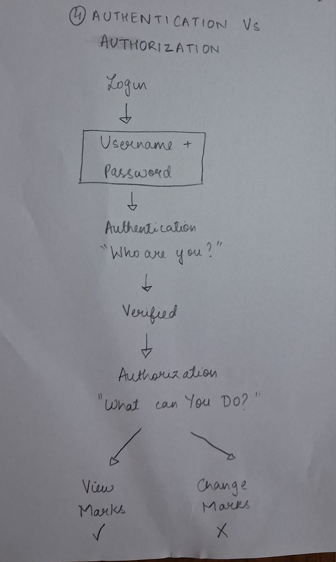

5. Threat vs Vulnerability vs Risk
These three terms are related,. They are not the same.
### Threat
A threat is something that could potentially cause harm.
For example a hacker trying to break into an account is a threat.
### Vulnerability
A vulnerability is a weakness that could be used to cause that harm.
For example using a weak password is a vulnerability.
### Risk
Risk is the possibility of something bad happening because a threat can take advantage of a vulnerability.
### Real-World Scenario
Imagine that a student uses the password:
**student123**
for their college account.
A hacker trying to access the account is the threat.
The weak password is the vulnerability.
Because the hacker may be able to guess the password and access the account there is a risk of the account being compromised.
The three ideas can therefore be connected like this:
**Threat + Vulnerability → Risk**
The risk can be reduced by fixing the vulnerability. In this example the student could use an unique password and enable additional login protection if available.
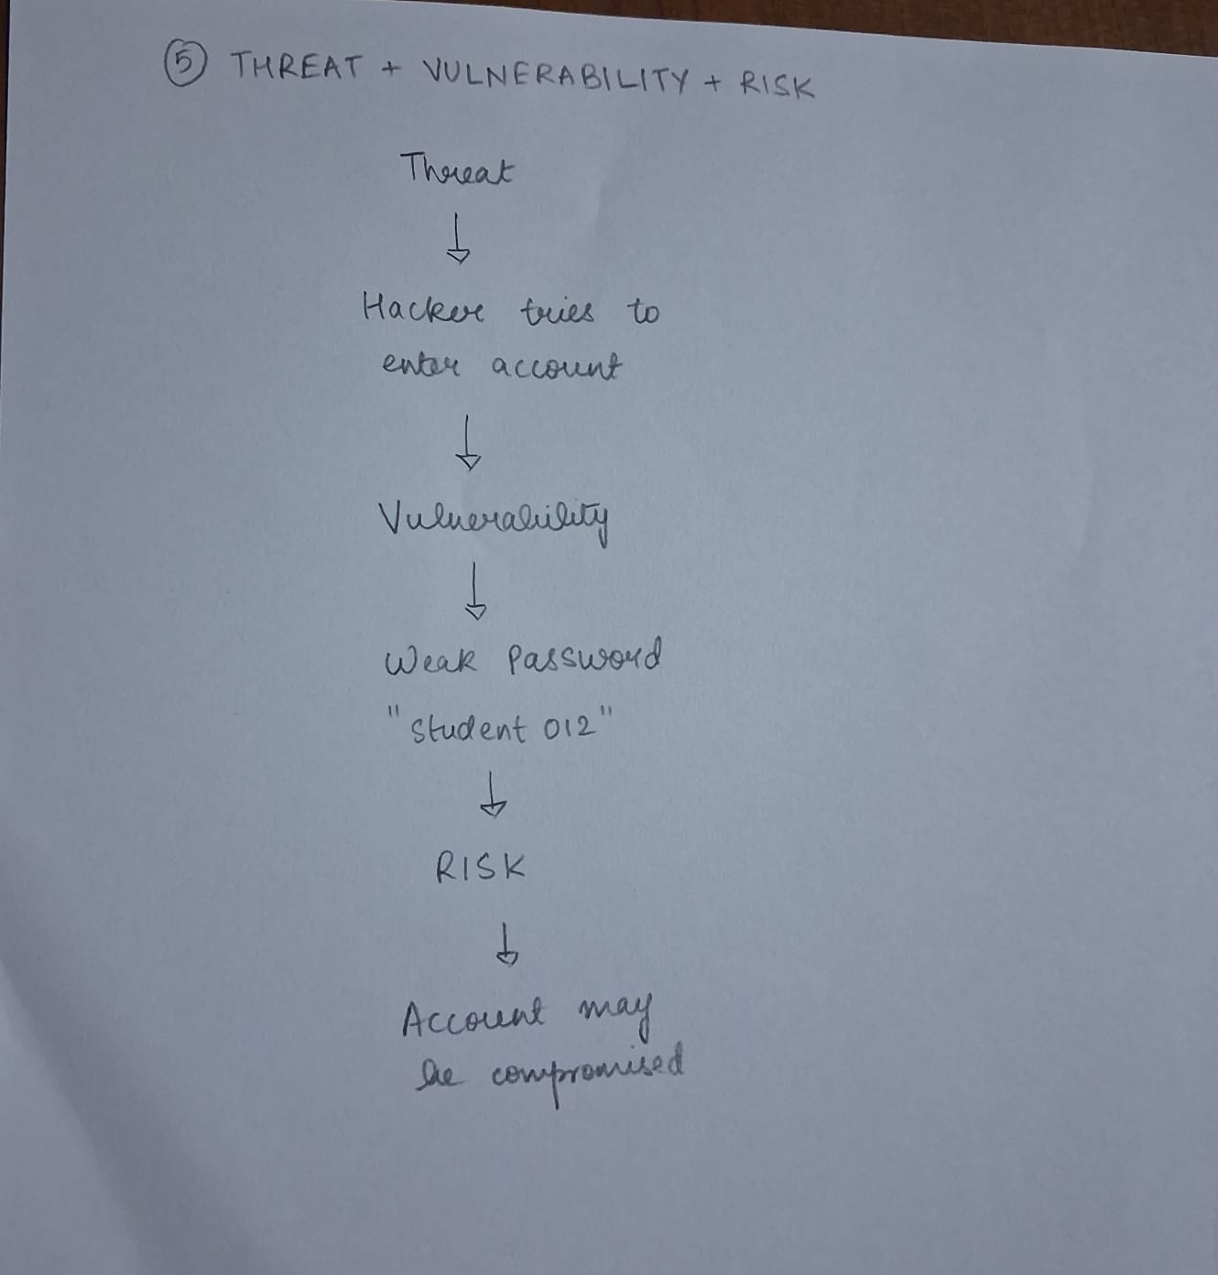

The five concepts explained above are some of the ideas that are used in cybersecurity.
The CIA Triad helps us think about protecting information in three ways:
* Confidentiality – only the right people can see it.
* Integrity – the information stays correct.
* Availability – the information or service is available when needed.
Authentication and authorization help control who can access a system and what they can do.
Finally understanding threats, vulnerabilities and risks helps us identify how security problems can happen. What can be done to reduce them.
These concepts are simple on their own. They form the foundation, for understanding more advanced cybersecurity topics.

R.SAHANNA
CSE E

